15

Evidence & Causes 2020

and horizontal variations of winds.

warming, but uncertainty exists in other factors that affect tornado formation, such as changes in the vertical

Some conditions favourable for strong thunderstorms that spawn tornadoes are expected to increase with

each year is quite uncertain. This remains a subject of ongoing research.

While global warming is likely making hurricanes more intense, the change in the number of hurricanes

along with more rainfall produced by the storms, can result in more destructive storm surges and ﬂooding.

Question 14) increases the amount of seawater that is pushed on to shore during coastal storms, which,

is supported by available observational evidence in the North Atlantic. In addition, sea level rise (see

will be more intense, produce more rainfall, affect new areas, and possibly be larger and longer-lived. This

Earth’s warmer and moister atmosphere and warmer oceans make it likely that the strongest hurricanes

a warming climate.

conditions in many places. These short-term and regional variations are expected to become more extreme in

events favour drought in many tropical and subtropical land areas, while La Niña events promote wetter

precipitation events (rain and snowstorms) through increases in the air’s capacity to hold moisture. El Niño

more prone to wildﬁre and a longer wildﬁre season. A warming atmosphere is also associated with heavier

nights. Climate warming also increases evaporation on land, which can worsen drought and create conditions

A warming climate can contribute to the intensity of heat waves by increasing the chances of very hot days and

studies can show whether the warming climate made an event more severe or more likely to happen.

making it challenging to attribute any particular extreme event to human-caused climate change. However,

extreme weather event—including patterns of natural climate variability, such as El Niño and La Niña—

of similar weather events that happened before in the same region. Many factors contribute to any individual

around the world. Scientists typically identify these weather events as “extreme” if they are unlike 90% or 95%

As Earth’s climate has warmed, more frequent and more intense weather events have both been observed

generally becoming more frequent.

more likely. Heavy rainfall and snowfall events (which increase the risk of ﬂooding) are also

closely related to temperature, such as heatwaves and extremely hot days, are becoming

extreme weather events. Consistent with theoretical expectations, the types of events most

greenhouse gas emissions. This gives the potential for more energy for storms and certain

Earth’s lower atmosphere is becoming warmer and moister as a result of human-caused

droughts, hurricanes, and tornadoes?

13

strength and frequency of floods,

How does climate change affect the

Q& A n



16

storm surges. If CO

and other greenhouse gases continue to increase on their current trajectories, it is

2

projected that sea level may rise, at minimum, by a further 0.4 to 0.8 m (1.3 to 2.6 feet) by 2100, although

future ice sheet melt could make these values considerably higher. Moreover, rising sea levels will not

stop in 2100; sea levels will be much higher in the following centuries as the sea continues to take up

heat and glaciers continue to retreat. It remains difﬁcult to predict the details of how the Greenland and

Antarctic Ice Sheets will respond to continued warming, but it is thought that Greenland and perhaps

West Antarctica will continue to lose mass, whereas the colder parts of Antarctica could gain mass as

they receive more snowfall from warmer air that contains more moisture. Sea level in the last interglacial

(warm) period around 125,000 years ago peaked at probably 5 to 10 m above the present level. During this

period, the polar regions were warmer than they are today. This suggests that, over millennia, long periods

Figure .

Observations show

of increased warmth will lead to very signiﬁcant loss of parts of the Greenland and Antarctic Ice Sheets

that the global average sea level

and to consequent sea level rise.

has risen by about 16 cm (6 inches)

th

since the late 19

century. Sea level

is rising faster in recent decades;

measurements from tide gauges

(blue) and satellites (red) indicate

that the best estimate for the

average sea level rise over the last

decade is centred on 3.6 mm per

year (0.14 inches per year). The

shaded area represents the sea level

uncertainty, which has decreased

as the number of gauge sites used

in calculating the global averages

and the number of data points have

increased. Source: Shum and Kuo (2011)

Climate Change

The effects of rising sea level are felt most acutely in the increased frequency and intensity of occasional

currents are piling ocean water against some coasts or moving water away.

down by previous ice sheets are causing the land itself to rise or sink, and whether changes in winds and

variety of other factors, including whether regional geological processes and rebound of the land weighted

water stored on land. The amount of sea level change experienced at any given location also depends on a

these result from a warming climate. Fluctuations in sea level also occur due to changes in the amounts of

glaciers in all regions of the world, and mass losses from the Greenland and Antarctic ice sheets. All of

This sea level rise has been driven by expansion of water volume as the ocean warms, melting of mountain

.

[Figure ]

rise since 1902 is about 16 cm (6 inches)

global-average sea level rise since 1970 is human-caused warming. The overall observed

measurements using altimetry from space were started in 1992; the dominant factor in

being 3.6 mm per year (0.14 inches per year). The rate of sea level rise has increased since

level is rising, with the best estimate of the rate of global-average rise over the last decade

14

Long-term measurements of tide gauges and recent satellite data show that global sea

How fast is sea level rising?

n Q& A

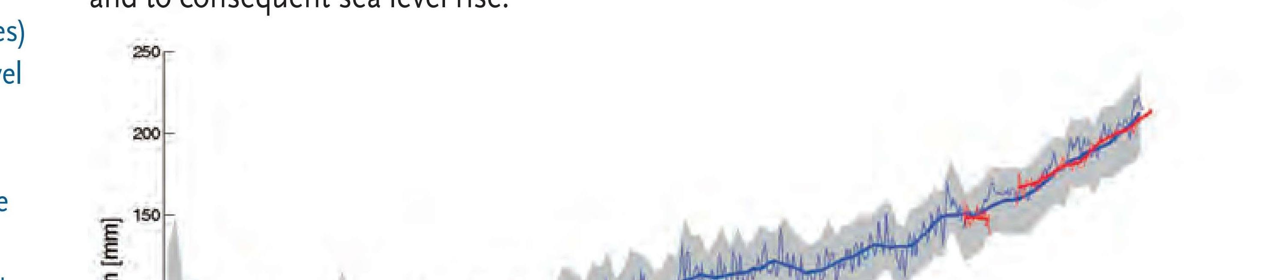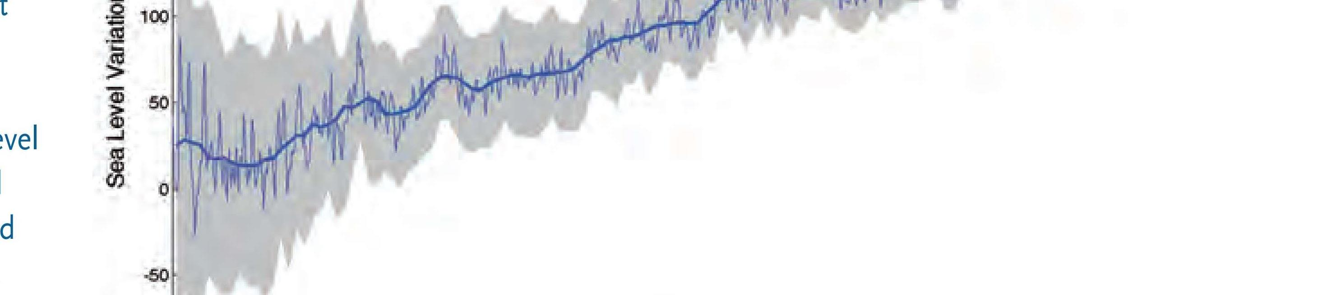

As CO

in the air has

2

increased, there has been an

increase in the CO

content of the

2

surface ocean (upper box), and a

decrease in the seawater pH (lower

box). Source: adapted from Dore et al.

(2009) and Bates et al. (2012).

figure .

CO

dissolves in water to form a weak acid, and the oceans have absorbed about a third of the CO

resulting

2

2

from human activities, leading to a steady decrease in ocean pH levels. With increasing atmospheric CO

,

2

this chemical balance will change even more during the next century. Laboratory and other experiments

show that under high CO

and in more acidic waters, some marine species have misshapen shells and

2

lower growth rates, although the effect varies among species. Acidiﬁcation also alters the cycling of

nutrients and many other elements and compounds in the ocean, and it is likely to shift the competitive

340

advantage among species, with as-yet-to-be-determined impacts on marine ecosystems and the food web.

400

Atmospheric CO

concentration (ppm)

2

Surface Ocean pCO

, Bermuda (μatm)

2

390

Surface Ocean pCO

, Hawaii (μatm)

2

380

370

360

350

330

320

8.11

8.10

8.09

8.08

Surface Ocean pH

8.07

Bermuda

Hawaii

8.06

1990

1995

2000

2005

2010

Year

Evidence & Causes 2020

17

these organisms to form or maintain their shells.

more readily in acid. As the acidity of sea water increases, it becomes more difﬁcult for

corals and some shellﬁsh) have shells composed of calcium carbonate, which dissolves

. Some marine organisms (such as

[Figure ]

has shifted to a more acidic state (lower pH)

Direct observations of ocean chemistry have shown that the chemical balance of seawater

15

does it matter?

What is ocean acidification and why

Q& A n

